Lab – Configuring EtherChannel

1. Topology

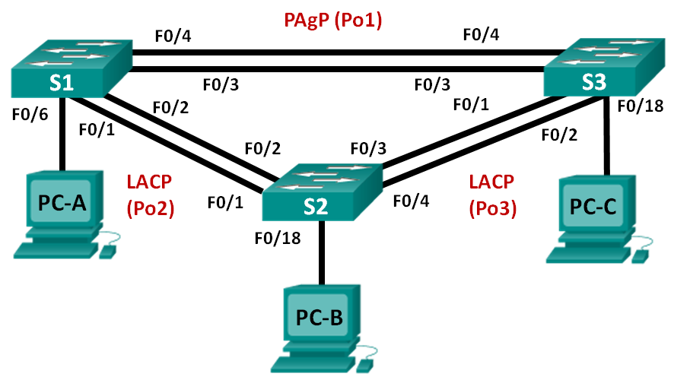

1. Addressing Table

|  |  |  |  |
| --- | --- | --- | --- |
| Device | Interface | IP Address | Subnet Mask |
| S1 | VLAN 99 | 192.168.99.11 | 255.255.255.0 |
| S2 | VLAN 99 | 192.168.99.12 | 255.255.255.0 |
| S3 | VLAN 99 | 192.168.99.13 | 255.255.255.0 |
| PC-A | NIC | 192.168.10.1 | 255.255.255.0 |
| PC-B | NIC | 192.168.10.2 | 255.255.255.0 |
| PC-C | NIC | 192.168.10.3 | 255.255.255.0 |

1. Objectives

Part 1: Configure Basic Switch Settings

Part 2: Configure PAgP

Part 3: Configure LACP

1. Background / Scenario

Link aggregation allows the creation of logical links that are comprised of two or more physical links. This provides increased throughput beyond using only one physical link. Link aggregation also provides redundancy if one of the links fails.

In this lab, you will configure EtherChannel, a form of link aggregation used in switched networks. You will configure EtherChannel using Port Aggregation Protocol (PAgP) and Link Aggregation Control Protocol (LACP).

**Note**: PAgP is a Cisco-proprietary protocol that you can only run on Cisco switches and on switches that are licensed vendors to support PAgP. LACP is a link aggregation protocol that is defined by IEEE 802.3ad, and it is not associated with any specific vendor.

LACP allows Cisco switches to manage Ethernet channels between switches that conform to the 802.3ad protocol. You can configure up to 16 ports to form a channel. Eight of the ports are in active mode and the other eight are in standby mode. When any of the active ports fail, a standby port becomes active. Standby mode works only for LACP, not for PAgP.

**Note**: The switches used with CCNA hands-on labs are Cisco Catalyst 2960s with Cisco IOS Release 15.0(2) (lanbasek9 image). Other switches and Cisco IOS versions can be used. Depending on the model and Cisco IOS version, the commands available and output produced might vary from what is shown in the labs.

**Note**: Make sure that the switches have been erased and have no startup configurations. If you are unsure, contact your instructor.

1. Required Resources

* 3 Switches (Cisco 2960 with Cisco IOS Release 15.0(2) lanbasek9 image or comparable)
* 3 PCs (Windows 7, Vista, or XP with terminal emulation program, such as Tera Term)
* Console cables to configure the Cisco IOS devices via the console ports
* Ethernet cables as shown in the topology

1. Configure Basic Switch Settings

In Part 1, you will set up the network topology and configure basic settings, such as the interface IP addresses, device access, and passwords.

* 1. Cable the network as shown in the topology.

Attach the devices as shown in the topology diagram, and cable as necessary.

* 1. Initialize and reload the switches.
  2. Configure basic settings for each switch.
     1. Disable DNS lookup.
     2. Configure the device name as displayed in the topology.
     3. Encrypt plain text passwords.
     4. Create a MOTD banner warning users that unauthorized access is prohibited.
     5. Assign **class** as the encrypted privileged EXEC mode password.
     6. Assign **cisco** as the console and vty password and enable login.
     7. Configure logging synchronous to prevent console message from interrupting command entry.
     8. Shut down all switchports except the ports connected to PCs.
     9. Configure VLAN 99 and name it **Management**.
     10. Configure VLAN 10 and name it **Staff**.
     11. Configure the switch ports with attached hosts as access ports in VLAN 10.
     12. Assign the IP addresses according to the Addressing Table.
     13. Copy the running configuration to startup configuration.
  3. Configure the PCs.

Assign IP addresses to the PCs according to the Addressing Table.

1. Configure PAgP

PAgP is a Cisco proprietary protocol for link aggregation. In Part 2, a link between S1 and S3 will be configured using PAgP.

* 1. Configure PAgP on S1 and S3.

For a link between S1 and S3, configure the ports on S1 with PAgP desirable mode and the ports on S3 with PAgP auto mode. Enable the ports after PAgP modes have been configured.

S1(config)# **interface range f0/3-4**

S1(config-if-range)# **channel-group 1 mode desirable**

Creating a port-channel interface Port-channel 1

S1(config-if-range)# **no shutdown**

S3(config)# **interface range f0/3-4**

S3(config-if-range)# **channel-group 1 mode auto**

Creating a port-channel interface Port-channel 1

S3(config-if-range)# **no shutdown**

*Mar 1 00:09:12.792: %LINK-3-UPDOWN: Interface FastEthernet0/3, changed state to up

*Mar 1 00:09:12.792: %LINK-3-UPDOWN: Interface FastEthernet0/4, changed state to up

S3(config-if-range)#

*Mar 1 00:09:15.384: %LINEPROTO-5-UPDOWN: Line protocol on Interface FastEthernet0/3, changed state to up

*Mar 1 00:09:16.265: %LINEPROTO-5-UPDOWN: Line protocol on Interface FastEthernet0/4, changed state to up

S3(config-if-range)#

*Mar 1 00:09:16.357: %LINK-3-UPDOWN: Interface Port-channel1, changed state to up

*Mar 1 00:09:17.364: %LINEPROTO-5-UPDOWN: Line protocol on Interface Port-channel1, changed state to up

*Mar 1 00:09:44.383: %LINEPROTO-5-UPDOWN: Line protocol on Interface Vlan1, changed state to up

* 1. Examine the configuration on the ports.

Currently the F0/3, F0/4, and Po1 (Port-channel1) interfaces on both S1 and S3 are in access operational mode with the administrative mode in dynamic auto. Verify the configuration using the **show run interface** *interface-id* and **show interfaces** *interface-id***switchport** commands, respectively. The example configuration outputs for F0/3 on S1 are as follows:

S1# **show run interface f0/3**

Building configuration...

Current configuration : 103 bytes

!

interface FastEthernet0/3

channel-group 1 mode desirable

S1# **show interfaces f0/3 switchport**

Name: Fa0/3

Switchport: Enabled

Administrative Mode: dynamic auto

Operational Mode: static access (member of bundle Po1)

Administrative Trunking Encapsulation: dot1q

Operational Trunking Encapsulation: native

Negotiation of Trunking: On

Access Mode VLAN: 1 (default)

Trunking Native Mode VLAN: 1 (default)

Administrative Native VLAN tagging: enabled

Voice VLAN: none

Administrative private-vlan host-association: none

Administrative private-vlan mapping: none

Administrative private-vlan trunk native VLAN: none

Administrative private-vlan trunk Native VLAN tagging: enabled

Administrative private-vlan trunk encapsulation: dot1q

Administrative private-vlan trunk normal VLANs: none

Administrative private-vlan trunk associations: none

Administrative private-vlan trunk mappings: none

Operational private-vlan: none

Trunking VLANs Enabled: ALL

Pruning VLANs Enabled: 2-1001

Capture Mode Disabled

Capture VLANs Allowed: ALL

Protected: false

Unknown unicast blocked: disabled

Unknown multicast blocked: disabled

Appliance trust: none

* 1. Verify that the ports have been aggregated.

S1# **show etherchannel summary**

Flags: D - down P - bundled in port-channel

I - stand-alone s - suspended

H - Hot-standby (LACP only)

R - Layer3 S - Layer2

U - in use f - failed to allocate aggregator

M - not in use, minimum links not met

u - unsuitable for bundling

w - waiting to be aggregated

d - default port

Number of channel-groups in use: 1

Number of aggregators: 1

Group Port-channel Protocol Ports

------+-------------+-----------+-----------------------------------------------

1 Po1(SU) PAgP Fa0/3(P) Fa0/4(P)

S3# **show etherchannel summary**

Flags: D - down P - bundled in port-channel

I - stand-alone s - suspended

H - Hot-standby (LACP only)

R - Layer3 S - Layer2

U - in use f - failed to allocate aggregator

M - not in use, minimum links not met

u - unsuitable for bundling

w - waiting to be aggregated

d - default port

Number of channel-groups in use: 1

Number of aggregators: 1

Group Port-channel Protocol Ports

------+-------------+-----------+-----------------------------------------------

1 Po1(SU) PAgP Fa0/3(P) Fa0/4(P)

What do the flags, SU and P, indicate in the Ethernet summary?

_______________________________________________________________________________________

_______________________________________________________________________________________

* 1. Configure trunk ports.

After the ports have been aggregated, commands applied at the port channel interface affect all the links that were bundled together. Manually configure the Po1 ports on S1 and S3 as trunk ports and assign them to native VLAN 99.

S1(config)# **interface port-channel 1**

S1(config-if)# **switchport mode trunk**

S1(config-if)# **switchport trunk native vlan 99**

S3(config)# **interface port-channel 1**

S3(config-if)# **switchport mode trunk**

S3(config-if)# **switchport trunk native vlan 99**

* 1. Verify that the ports are configured as trunk ports.
     1. Issue the **show run** **interface** *interface-id* commands on S1 and S3. What commands are listed for F0/3 and F0/4 on both switches? Compare the results to the running configuration for the Po1 interface? Record your observation.

____________________________________________________________________________________

____________________________________________________________________________________

* + 1. Issue the **show interfaces trunk** and **show spanning-tree** commands on S1 and S3. What trunk port is listed? What is the native VLAN? What is concluding result from the output?

____________________________________________________________________________________

____________________________________________________________________________________

From the **show spanning-tree** output, what is port cost and port priority for the aggregated link?

____________________________________________________________________________________

1. Configure LACP

LACP is an open source protocol for link aggregation developed by the IEEE. In Part 3, the link between S1 and S2, and the link between S2 and S3 will be configured using LACP. Also, the individual links will be configured as trunks before they are bundled together as EtherChannels.

* 1. Configure LACP between S1 and S2.

S1(config)# **interface range f0/1-2**

S1(config-if-range)# **switchport mode trunk**

S1(config-if-range)# **switchport trunk native vlan 99**

S1(config-if-range)# **channel-group 2 mode active**

Creating a port-channel interface Port-channel 2

S1(config-if-range)# **no shutdown**

S2(config)# **interface range f0/1-2**

S2(config-if-range)# **switchport mode trunk**

S2(config-if-range)# **switchport trunk native vlan 99**

S2(config-if-range)# **channel-group 2 mode passive**

Creating a port-channel interface Port-channel 2

S2(config-if-range)# **no shutdown**

* 1. Verify that the ports have been aggregated.

What protocol is Po2 using for link aggregation? Which ports are aggregated to form Po2? Record the command used to verify.

_______________________________________________________________________________________

_______________________________________________________________________________________

* 1. Configure LACP between S2 and S3.
     1. Configure the link between S2 and S3 as Po3 and use LACP as the link aggregation protocol.

S2(config)# **interface range f0/3-4**

S2(config-if-range)# **switchport mode trunk**

S2(config-if-range)# **switchport trunk native vlan 99**

S2(config-if-range)# **channel-group 3 mode active**

Creating a port-channel interface Port-channel 3

S2(config-if-range)# **no shutdown**

S3(config)# **interface range f0/1-2**

S3(config-if-range)# **switchport mode trunk**

S3(config-if-range)# **switchport trunk native vlan 99**

S3(config-if-range)# **channel-group 3 mode passive**

Creating a port-channel interface Port-channel 3

S3(config-if-range)# **no shutdown**

* + 1. Verify that the EtherChannel has formed.
  1. Verify end-to-end connectivity.

Verify that all devices can ping each other within the same VLAN. If not, troubleshoot until there is end-to-end connectivity.

**Note**: It may be necessary to disable the PC firewall to ping between PCs.

1. Reflection

What could prevent EtherChannels from forming?

_______________________________________________________________________________________

_______________________________________________________________________________________

_______________________________________________________________________________________